Ex 2: Setting Up a Zoho Creator Account and Exploring the Platform Architecture and Interface
Name : Priyan S
Roll no : 240701402

Aim :
To register a Zoho Creator account and understand the basic features of the platform.To create a simple application and learn how forms, reports, and dashboards work
together.

Creating a Zoho Creator Account

Step 1: Account Registration

  - Visit the Zoho Creator website.
  - Register using a valid email address.
  - Verify the account through email.
  - Log in and access the Zoho Creator workspace.

Screenshot 1: Zoho Creator Home Page
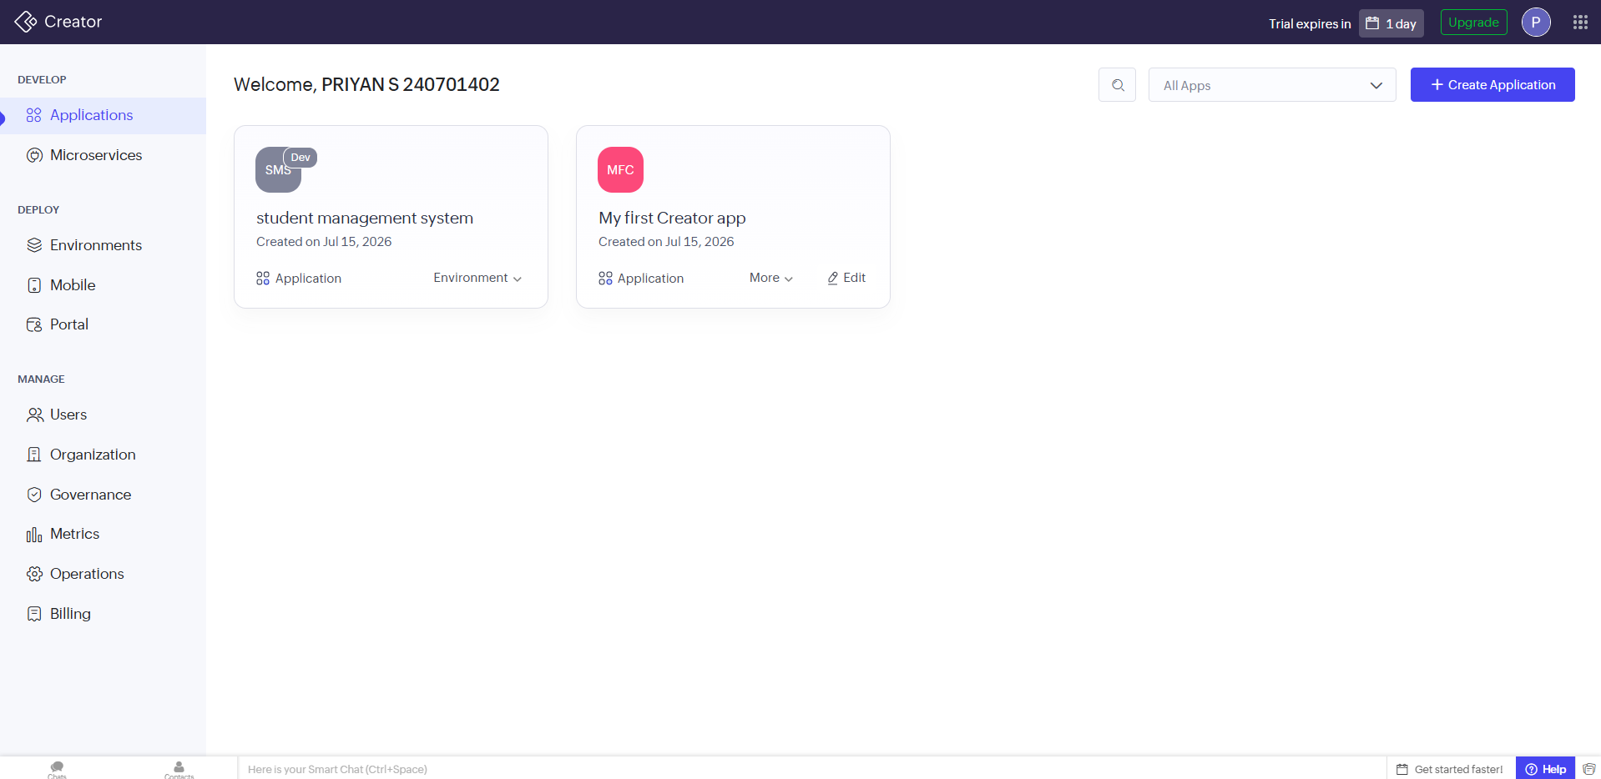

Step 2: Developing a Sample Application

Create an application named Student Management System (or Employee Information System, Library Management System).

The application contains:

  - Student Information Form
  - Student Records Report
  - Dashboard The form stores:
  - Student
  - Student Name
  - ID
  - Department
  - Year
  - Mobile Number
  - Email Address

Screenshot 2: Create New Application and gform
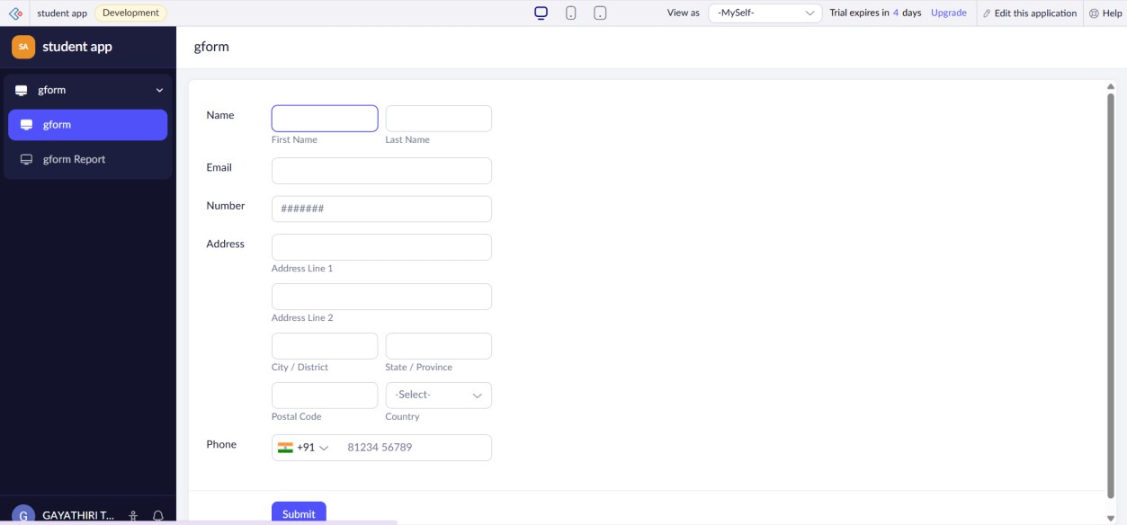

Screenshot 3 : GForm report
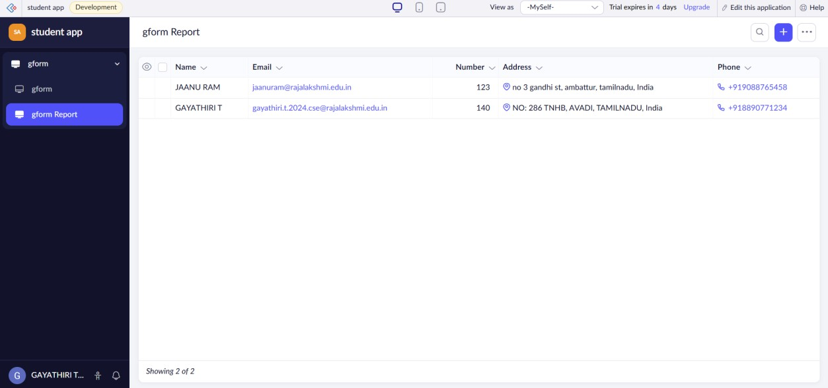

Dashboard

The application dashboard/home page displays all created applications and provides options to edit or create new applications.

Screenshot 4: Dashboard


Application Modules

Student Information Form
  - Used to collect student details.
  - Validates user input before saving.
  - Automatically stores records in the database.

Student Records Report
  - Displays all submitted records.
  - Allows searching and filtering.
  - Supports editing and deleting records.

Dashboard
  - Displays application summary.
  - Provides quick navigation to forms and reports.
  - Shows recently added records.
  - ​

Platform Architecture
- Forms – Capture user information.
- Data Storage – Securely stores submitted data.
- Reports – Display and manage records.
- Workflows – Automate actions like notifications and approvals.
- Pages – Create customized dashboards.
- User Management – Controls user roles and permissions.
- Integration – Connects with other Zoho applications.

Interface Components

  - Home Dashboard
  - Application Explorer
  - Form Builder
  - Report Builder
  - Workflow Section
  - Navigation Panel
  - Search Feature
  - Settings Menu
  - User Profile

  - Mobile Application Preview

Result

Successfully created a Zoho Creator account, built a sample application, explored different platform components, and gained practical knowledge of forms, reports, dashboards, workflows, and the overall Zoho Creator environment.
These points are different from your PDF, while still matching the same experiment format, so they are suitable for your record without being copied directly.

